def cube(x):

print("The volume is ", pow(x,3))

print("The surface area is ", 6*(pow(x,2)))

if __name__ == '__main__':

cube(7)

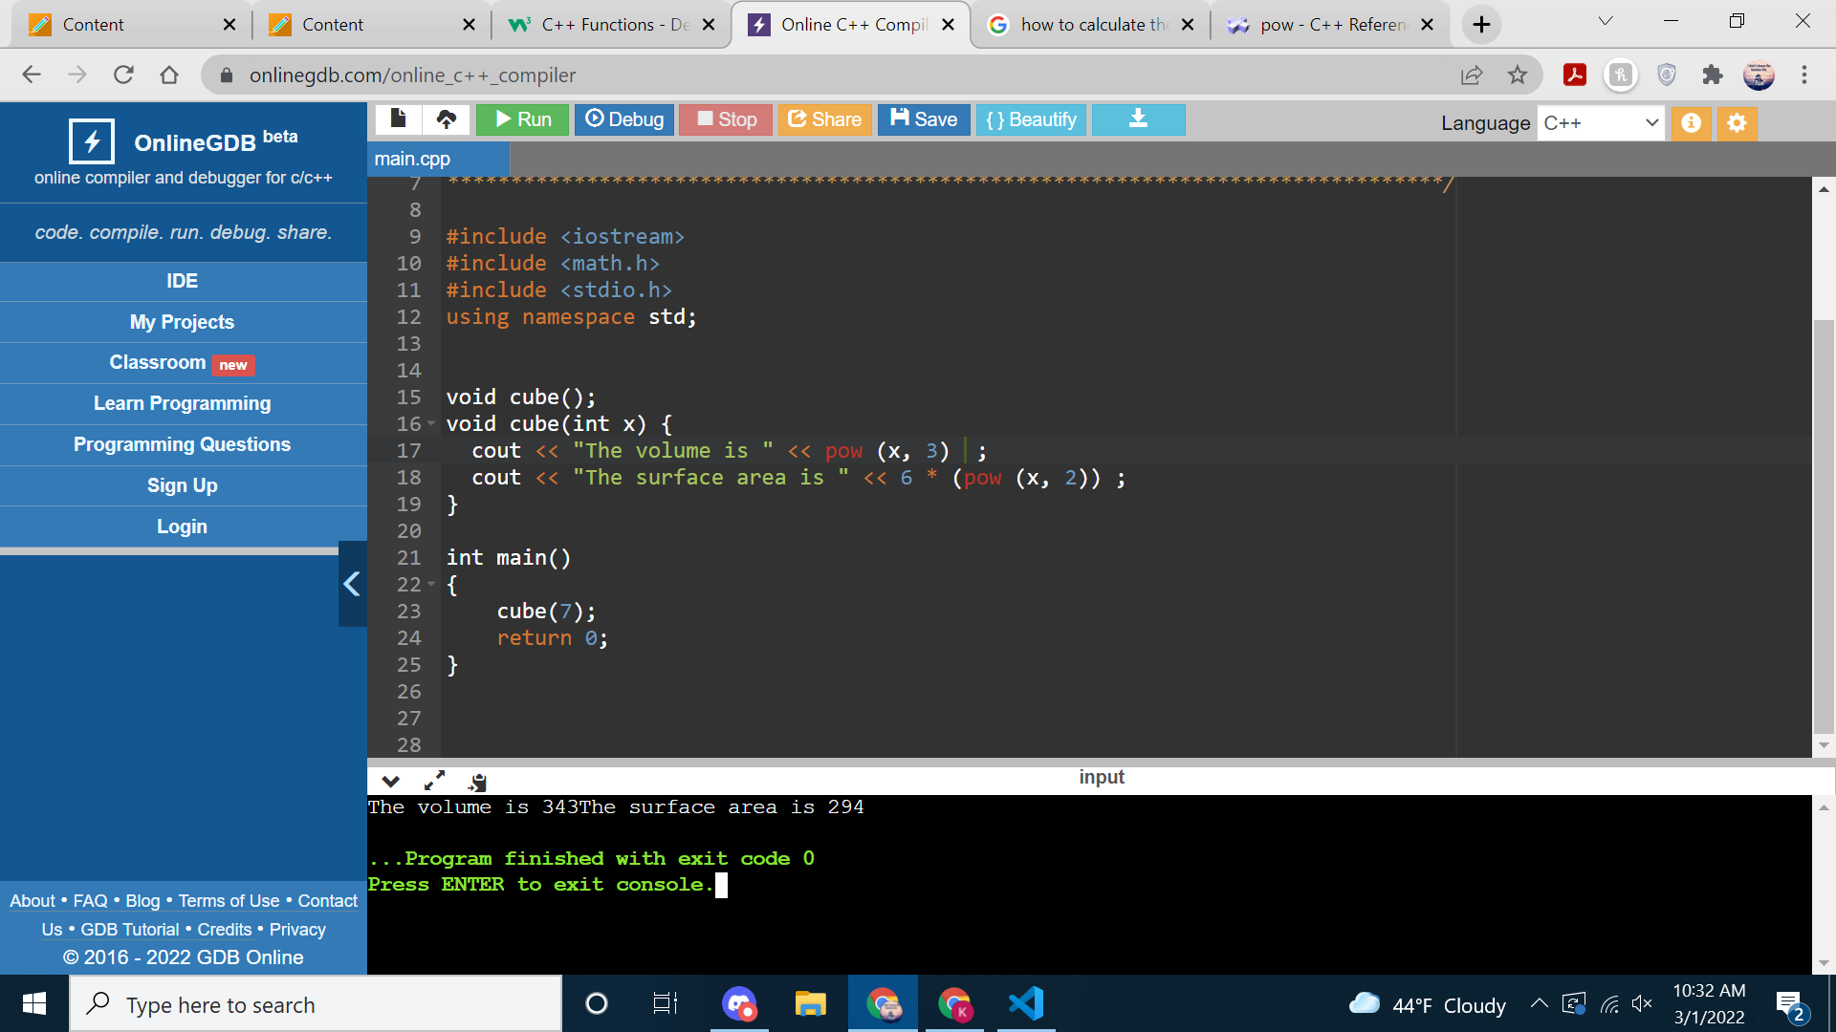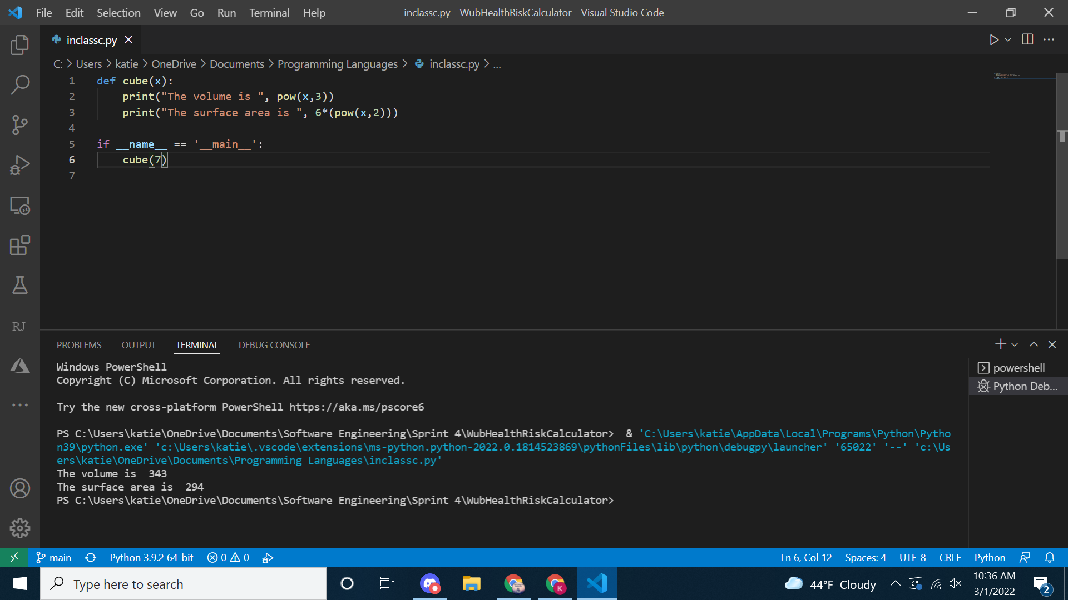#include <iostream>

#include <math.h>

#include <stdio.h>

using namespace std;

void cube();

void cube(int x) {

cout << "The volume is " << pow (x, 3) ;

cout << "The surface area is " << 6 * (pow (x, 2)) ;

}

int main()

{

cube(7);

return 0;

}

For this assignment I calculated the volume and surface area of a cube in python and C++. I found it interesting that both languages used the same mathematical strategy for numbers taken to the power of another number. I think python is easier because I have worked in it for two years now. I have not used C++ very often. I think these languages are fairly similar based on just the work that I have done with them. I know the organizationally python is a little better. I think that python would be good for database projects like an employee debate. The things I have done in C++ has been a little more tricky organizationally, and usually C++ is somewhat difficult for me to be able to read and see what is going on and when. I think C++ would be better for calculations and mathematics. C++ also computes faster compared to python but the syntax has a steep learning curve. C++ is also better for low level memory manipulation while python is better for lengthy projects. The criteria I look for as a student is the easiest to implement out of the languages I know.